

*CAR Management*

Faculty: Ho Hoan Kiem

Batch:

Team Member:

* Hoang Anh Thang
* Van Thanh Phuong Dat

**Ho Chi Minh City, March 30 2020**

Table of Contents

1. **Review 1**

* **Problem Definition ……………………………………………………… 04**
* **Customer Request Specification ……………………………………….. 05**

1. **Review 2**

* ***Use Case Diagram* ……………………………………………….. 10**
* ***Class Diagram* …………………………………………………… 14**
* ***ERD* ……………………………………………………………… 15**
* ***Entity Description* ……………………………………………….. 16**
* ***Table Design* …………………………………..…………………. 19**
* ***Table Relationship Diagram* …………………………………….. 22**
* ***Sequence Diagram* ………………………………………………. 23**

1. **Review 3**

* **Interface Design …….………………………………………………….... 32**
* **Tasksheet …………………………………………………………………. 46**

**REVIEW 1**

**Problem Definition**

1. **The Object Of The Project:**

This project will aim at creation of an application for managing a garage. This will be convenient and save time for users who need software for managing their showroom. This system provides the following facilities:

* Showroom management .
* Staff management.
* Recording bill of customer.
* Export statistics.

**Customer Request   
 Specification**

1. **Functional Requirements:**

Following is a list of functionalities of the system. More functionalities that you find appropriate can be added to this list:

* Users must have a valid Username and password to login to the system.
* After the valid user logs in he is shown the home form with a list of available cars and some relative controllers.
* On selecting the showroom that the customer wants to purchase and then clicking “Export bill”, a form is shown for the user to fill in the information of the customer, information of car, after that, the system will record the bill.
* Users can view the history of the export bill.
* Users can manage information of staff in a form with some controllers (Add/Delete/Edit/Search).
* Users can manage information about the showroom in a form with some controllers (Add/Delete/Edit/Search).
* Users can view monthly, daily statistics about revenue and profit.

# Hardware/ Software Requirements:

By adding new technologies such as ASP.NET 3.5, AJAX, Web Service and 3-tier architecture, the web site becomes more interactive with users, security and easily updated.

1. **System Requirement**

* **For Users**
  + **Hardware**
    - CPU: Pentium IV 2.0 GHz or higher
    - RAM: 512 MB or higher
  + **Software**
    - OS: Windows 7/XP Professional/Server 2003…
    - Browser: Internet Explorer 8.0 or higher
* **For Software Developers**
  + **Hardware**
    - CPU: Pentium IV 2.0 GHz or higher
    - RAM: 512 MB or higher
  + **Software**
    - OS: Windows XP Professional/Server 2003…
    - Environment: Microsoft .NET Framework 3.5
    - Database Management System: Microsoft SQL Server 2008
    - IDE: Microsoft Visual Studio 2010
    - Web Server: Internet Information Services (IIS) JSP / Servlets Dev. Kit

|  |  |  |
| --- | --- | --- |
| **Date: Sep 10, 2012** | **Prepared by Project Group 4**  **Team Leader:** | **Approved by**  **Mr Ho Hoan Kiem** |
| **Signature** |  |  |

**REVIEW 2**

**USE CASE DIAGRAM**

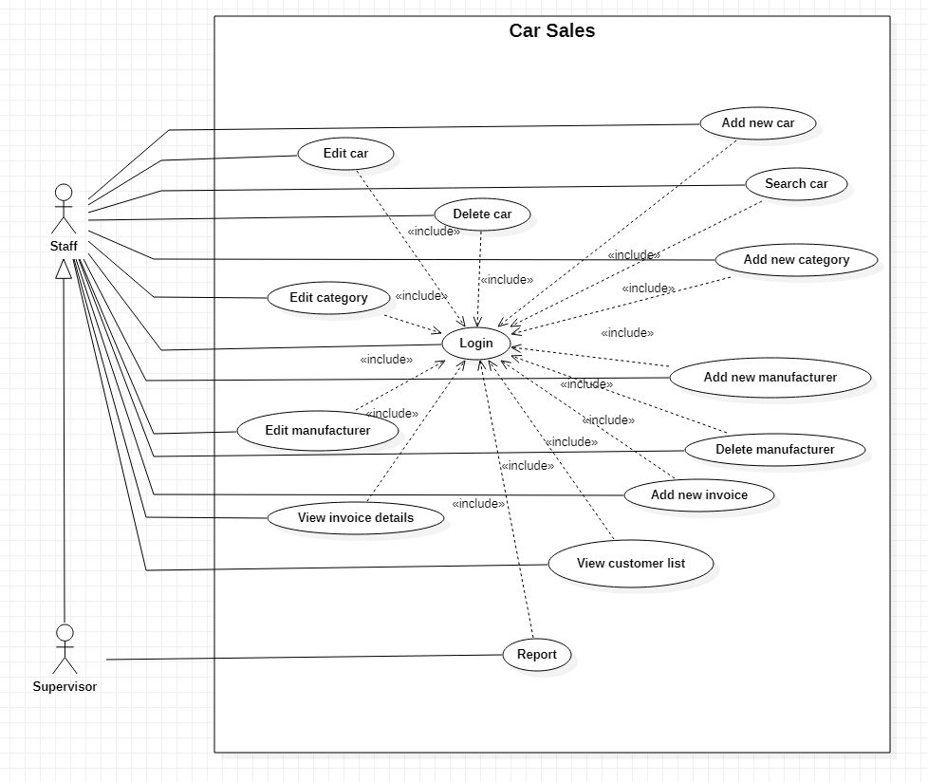

**USE CASE DESCRIPTION**

1. **Actor:**

**There are two actors in the Car Sales: staff and supervisor. While the staff actors are base specialisations, the supervisor class inherits from the staff actors as a generalisation.**

1. **Use case descriptions:**

|  |  |
| --- | --- |
| **Use case** | Login |
| **Short Description** | Login to the system to use many functions |
| **Pre-Conditions** |  |
| **Post-Conditions** |  |
| **Main flow** | _User inputs the login information :   * Username. * Password.   _User clicks on the Login button.  _System check the Username and Password.  _If Username and Password are valid, the system will move the user to Home form. |
| **Alternative flow(s)** | _If Username or Password is invalid the system will show a message to notify. |

|  |  |
| --- | --- |
| **Use case** | Add New Car |
| **Short Description** | Add new car infomations into the system. |
| **Pre-Conditions** |  |
| **Post-Conditions** |  |
| **Main flow** | _At Home form, the user clicks on the Car button on the menu on the left.  _Car control will show and the user clicks on the Add New Car button.  _User input all information of the new car in new form.  _Click Save button to finish. |
| **Alternative flow(s)** | _If any information input are invalid, system will notify the error. |

|  |  |
| --- | --- |
| **Use case** | Edit Car |
| **Short Description** | Edit car informations in the system. |
| **Pre-Conditions** |  |
| **Post-Conditions** |  |
| **Main flow** | _At Home form, the user clicks on the Car button on the menu on the left.  _Car control will show and the user clicks on the Edit Car button.  _User input all information of the new car in new form.  _Click Save button to finish. |
| **Alternative flow(s)** | _If any information edit are invalid, system will notify the error. |

|  |  |
| --- | --- |
| **Use case** | Delete Car |
| **Short Description** | Delete a car in the system. |
| **Pre-Conditions** |  |
| **Post-Conditions** |  |
| **Main flow** | _At Home form, the user clicks on the Car button on the menu on the left.  _Car control will show, user clicking on the DataGridView to select a car.  _User click Delete button to delete this car.  _A confirm form will show and user click Yes to finish. |
| **Alternative flow(s)** | _User click No on the confirm form and the system back to Car control and do nothing. |

|  |  |
| --- | --- |
| **Use case** | Search Car |
| **Short Description** | Search car by any information. |
| **Pre-Conditions** |  |
| **Post-Conditions** |  |
| **Main flow** | _At Home form, the user clicks on the Car button on the menu on the left.  _Car control will show, user input information for cars they want to find.  _User click Search button to get list car after search. |
| **Alternative flow(s)** | _If any information input are invalid, system will notify the error. |

|  |  |
| --- | --- |
| **Use case** | Add new category |
| **Short Description** | Add new car’s category to system. |
| **Pre-Conditions** |  |
| **Post-Conditions** |  |
| **Main flow** | _At Home form, users click on the Category button on the menu on the left.  _Category control will show, user clicking on the Add button.  _User input information for new category in new form.  _User click Save button to finish. |
| **Alternative flow(s)** | _If any information input are invalid, system will notify the error. |

|  |  |
| --- | --- |
| **Use case** | Edit category |
| **Short Description** | Edit information of a car’s category. |
| **Pre-Conditions** |  |
| **Post-Conditions** |  |
| **Main flow** | _At Home form, users click on the Category button on the menu on the left.  _Category control will show, user clicking on the Edit button.  _User input information for category in new form.  _User click Save button to finish. |
| **Alternative flow(s)** | _If any information edit are invalid, system will notify the error. |

|  |  |
| --- | --- |
| **Use case** | Add new manufacturer |
| **Short Description** | Add new car’s manufacturer to the system. |
| **Pre-Conditions** |  |
| **Post-Conditions** |  |
| **Main flow** | _At Home form, users click on the Manufacturer button on the menu on the left.  _Manufacturer control will show, user clicking on the Add button.  _User input information for new car’s manufacturer in new form.  _User click Save button to finish. |
| **Alternative flow(s)** | _If any information input are invalid, system will notify the error. |

|  |  |
| --- | --- |
| **Use case** | Edit manufacturer |
| **Short Description** | Edit car’s manufacturer informations. |
| **Pre-Conditions** |  |
| **Post-Conditions** |  |
| **Main flow** | _At Home form, users click on the Manufacturer button on the menu on the left.  _Manufacturer control will show, user clicking on the Edit button.  _User input information for car’s manufacturer in new form.  _User click Save button to finish. |
| **Alternative flow(s)** | _If any information edit are invalid, system will notify the error. |

|  |  |
| --- | --- |
| **Use case** | Delete manufacturer |
| **Short Description** | Delete a car’s manufacturer information. |
| **Pre-Conditions** |  |
| **Post-Conditions** |  |
| **Main flow** | _At Home form, users click on the Manufacturer button on the menu on the left.  _Manufacturer control will show, user clicking on the DataGridView to select a manufacturer.  _User click Delete button and click Yes when confirm form show to finish. |
| **Alternative flow(s)** | _If this manufacturer can’t be deleted, the system will notify the error.  _If users click No when confirmation form shows, the system goes back to Manufacturer control and do nothing. |

|  |  |
| --- | --- |
| **Use case** | Add Invoice |
| **Short Description** | Add new invoice information to the system. |
| **Pre-Conditions** |  |
| **Post-Conditions** |  |
| **Main flow** | _At Home form, users click on the Invoice button on the menu on the left.  _Invoice control will show, user click on Add button.  _User input information for new invoice in the new form.  _User click Save to finish. |
| **Alternative flow(s)** | _If any information input are invalid, system will notify the error. |

|  |  |
| --- | --- |
| **Use case** | View Invoice Details |
| **Short Description** | View invoice details information. |
| **Pre-Conditions** |  |
| **Post-Conditions** |  |
| **Main flow** | _At Home form, users click on the Invoice button on the menu on the left.  _Invoice control will show, user click to select a row on the DataGridView.  _User click Details button.  _A new form will show with detailed information about the selected invoice. |
| **Alternative flow(s)** | _If users don’t select any rows on the DataGridView and click Details,the system will do nothing. |

|  |  |
| --- | --- |
| **Use case** | View Customer List |
| **Short Description** | View customers’s information in the system. |
| **Pre-Conditions** |  |
| **Post-Conditions** |  |
| **Main flow** | _At Home form, the user clicks on the Customer button on the menu on the left.  _Customer control will show a DataGridView for customers' information. |
| **Alternative flow(s)** |  |

|  |  |
| --- | --- |
| **Use case** | View Report |
| **Short Description** | View column chart to report revenue for a year. |
| **Pre-Conditions** |  |
| **Post-Conditions** |  |
| **Main flow** | _At Home form, users click on the Invoice button on the menu on the left.  _Invoice control will show, user click Report button.  _A new form will show a column chart to report revenue for current year.  _User can choose year from combobox to load report for this selected year. |
| **Alternative flow(s)** | _If a staff click on the Report button the system will show a message to notify. |

**CLASS DIAGRAM**

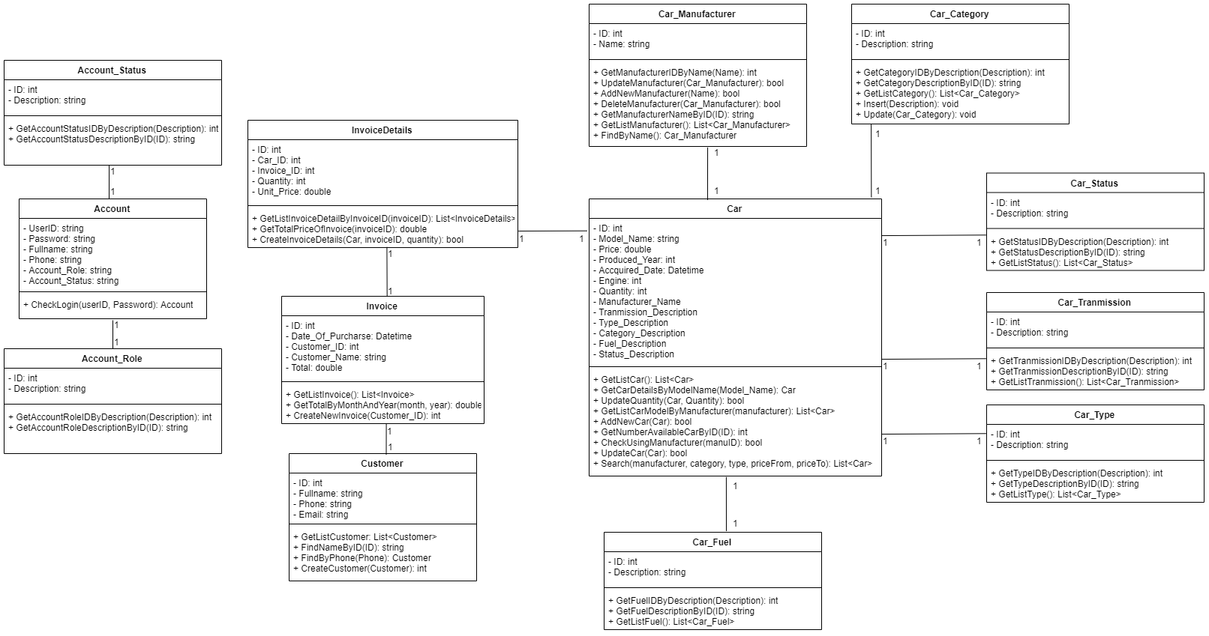

**ENTITY RELATIONSHIP DIAGRAM (ERD)  
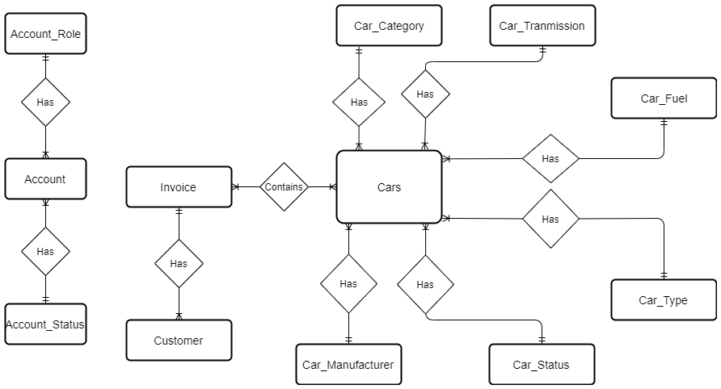**

**Note:  
  
ENTITY DESCRIPTION**

**1.Account:  
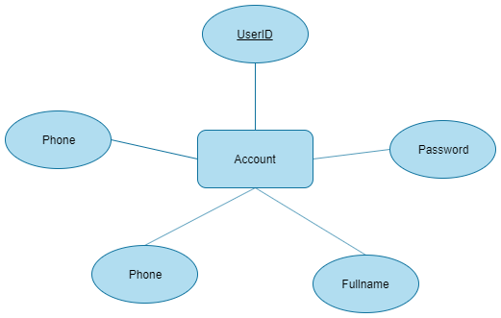**

**2. Account_Role:**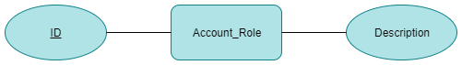

1. **Account_Status:**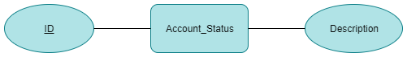

**4. Car:**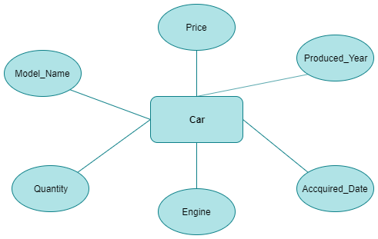

**5. Car_Manufacturer:  
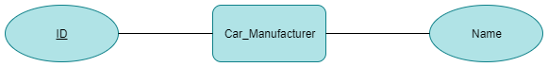  
6. Car_Tranmission:  
  
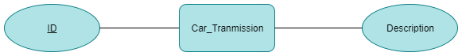  
7. Car_Fuel:**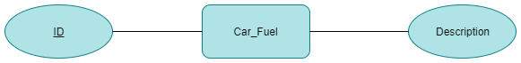

**8. Car_Category:**

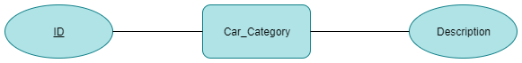

**9. Car_Type :**

**10. Car_Status:** 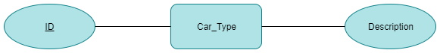

**11. Invoice:**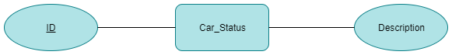

**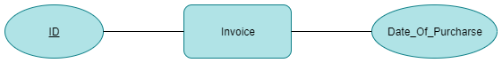  
12. Customer:**

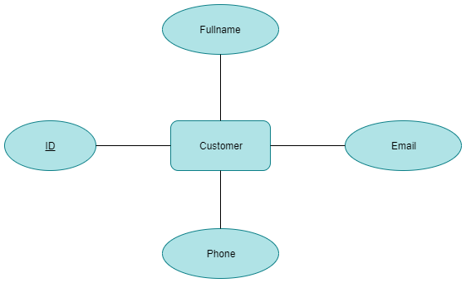

**TABLE DESIGN**

1. **Account:**

|  |  |  |  |  |  |
| --- | --- | --- | --- | --- | --- |
| **No** | **Column Name** | **Data Type** | **Size** | **Check** | **Description** |
| 1 | **** UserID | varchar | 50 | Not Null | UserID, Key |
| 2 | Passwords | varchar | 50 | Not Null | Account’s password |
| 3 | Fullname | nvarchar | 100 | Not Null | Account’s name |
| 4 | Phone | varchar | 50 | Not Null | Phone number |
| 5 | Account_Role_ID | int |  | Not Null | Role ID |
| 6 | Account_Status_ID | int |  | Not Null | Status ID |

1. **Account_Roles :**

|  |  |  |  |  |  |
| --- | --- | --- | --- | --- | --- |
| **No** | **Column Name** | **Data Type** | **Size** | **Check** | **Description** |
| 1 | **** ID | int | Identity | Not Null | ID |
| 2 | Description | nvarchar | 100 | Not Null | Description |

1. **Account_Status :**

|  |  |  |  |  |  |
| --- | --- | --- | --- | --- | --- |
| **No** | **Column Name** | **Data Type** | **Size** | **Check** | **Description** |
| 1 | **** ID | int | Identity | Not Null | ID |
| 2 | Description | nvarchar | 100 | Not Null | Description |

1. **Cars_Categories:**

|  |  |  |  |  |  |
| --- | --- | --- | --- | --- | --- |
| **No** | **Column Name** | **Data Type** | **Size** | **Check** | **Description** |
| 1 | **** ID | int | Identity | Not Null | ID |
| 2 | Description | nvarchar | 100 | Not Null | Description |

1. **Cars:**

|  |  |  |  |  |  |
| --- | --- | --- | --- | --- | --- |
| **No** | **Column Name** | **Data Type** | **Size** | **Check** | **Description** |
| 1 | **** ID | int | Identity | Not Null | Key |
| 2 | Model_Name | nvarchar | 100 | Not Null | Model |
| 3 | Price | float |  | Not Null | Price |
| 4 | Produced_Year | int |  | Not Null | Produced Year |
| 5 | Accquired_Date | datetime |  | Not Null | Acquired Date |
| 6 | Engine | int |  | Not Null | Engine |
| 7 | Quantity | int |  | Not Null | Quantity |
| 8 | Manufacturer_ID | int |  | Not Null | Manufacturer_ID |
| 9 | Tranmission_ID | int |  | Not Null | Tranmission_ID |
| 10 | Type_ID | int |  | Not Null | Type_ID |
| 11 | Category_ID | int |  | Not Null | Category_ID |
| 12 | Fuel_ID | int |  | Not Null | Fuel_ID |
| 13 | Status_ID | int |  | Not Null | Status_ID |

1. **Car_Fuels:**

|  |  |  |  |  |  |
| --- | --- | --- | --- | --- | --- |
| **No** | **Column Name** | **Data Type** | **Size** | **Check** | **Description** |
| 1 | **** ID | int | Identity | Not Null | ID |
| 2 | Description | nvarchar | 100 | Not Null | Description |

1. **Car_Manufacturers:**

|  |  |  |  |  |  |
| --- | --- | --- | --- | --- | --- |
| **No** | **Column Name** | **Data Type** | **Size** | **Check** | **Description** |
| 1 | **** ID | int | Identity | Not Null | ID |
| 2 | Name | nvarchar | 100 | Not Null | Name |

1. **Car_Status:**

|  |  |  |  |  |  |
| --- | --- | --- | --- | --- | --- |
| **No** | **Column Name** | **Data Type** | **Size** | **Check** | **Description** |
| 1 | **** ID | int | Identity | Not Null | ID |
| 2 | Description | nvarchar | 100 | Not Null | Description |

1. **Car_Tranmission:**

|  |  |  |  |  |  |
| --- | --- | --- | --- | --- | --- |
| **No** | **Column Name** | **Data Type** | **Size** | **Check** | **Description** |
| 1 | **** ID | int | Identity | Not Null | ID |
| 2 | Description | nvarchar | 100 | Not Null | Description |

1. **Car_Types:**

|  |  |  |  |  |  |
| --- | --- | --- | --- | --- | --- |
| **No** | **Column Name** | **Data Type** | **Size** | **Check** | **Description** |
| 1 | **** ID | int | Identity | Not Null | ID |
| 2 | Description | nvarchar | 100 | Not Null | Description |

1. **Invoice_Details:**

|  |  |  |  |  |  |
| --- | --- | --- | --- | --- | --- |
| **No** | **Column Name** | **Data Type** | **Size** | **Check** | **Description** |
| 1 | **** ID | int | Identity | Not Null | ID, Key |
| 2 | Car_ID | int |  | Not Null | CarID |
| 3 | Invoice_ID | int |  | Not Null | Invoice_ID |
| 4 | Unit_Price | float |  | Not Null | Unit_Price |
| 5 | Quantity | int |  | Not Null | Quantity |

1. **Invoice:**

|  |  |  |  |  |  |
| --- | --- | --- | --- | --- | --- |
| **No** | **Column Name** | **Data Type** | **Size** | **Check** | **Description** |
| 1 | **** ID | int | Identity | Not Null | ID, Key |
| 2 | Date_Of_Purcharse | datetime |  | Not Null | Date_Of_Purcharse |
| 3 | Customer_ID | int |  | Not Null | Customer_ID |

1. **Customers:**

|  |  |  |  |  |  |
| --- | --- | --- | --- | --- | --- |
| **No** | **Column Name** | **Data Type** | **Size** | **Check** | **Description** |
| 1 | **** ID | int | Identity | Not Null | ID, Key |
| 2 | Fullname | nvarchar | 100 | Not Null | Fullname |
| 3 | Phone | varchar | 50 | Not Null | Phone |
| 4 | Email | varchar | 100 | Not Null | Email |

**Note**

**** Primary key

✔ Unique constraint**TABLE RELATIONSHIP DIAGRAM**

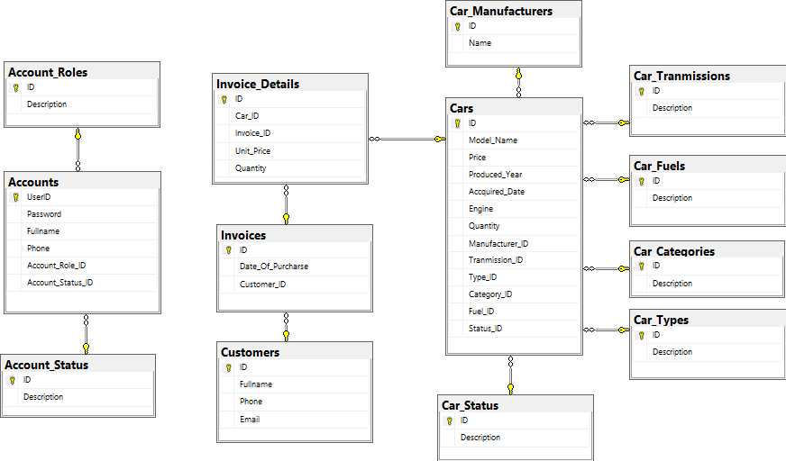

**Sequence Diagram**

**1)Login:**

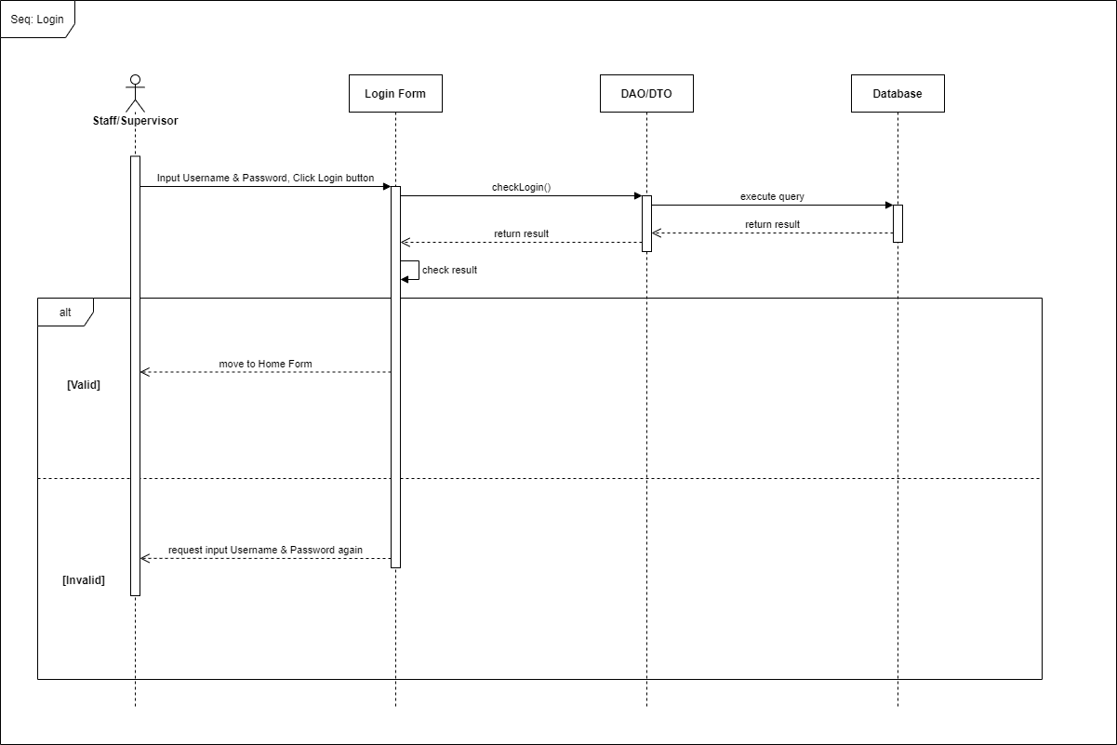

**2) Add Car:**

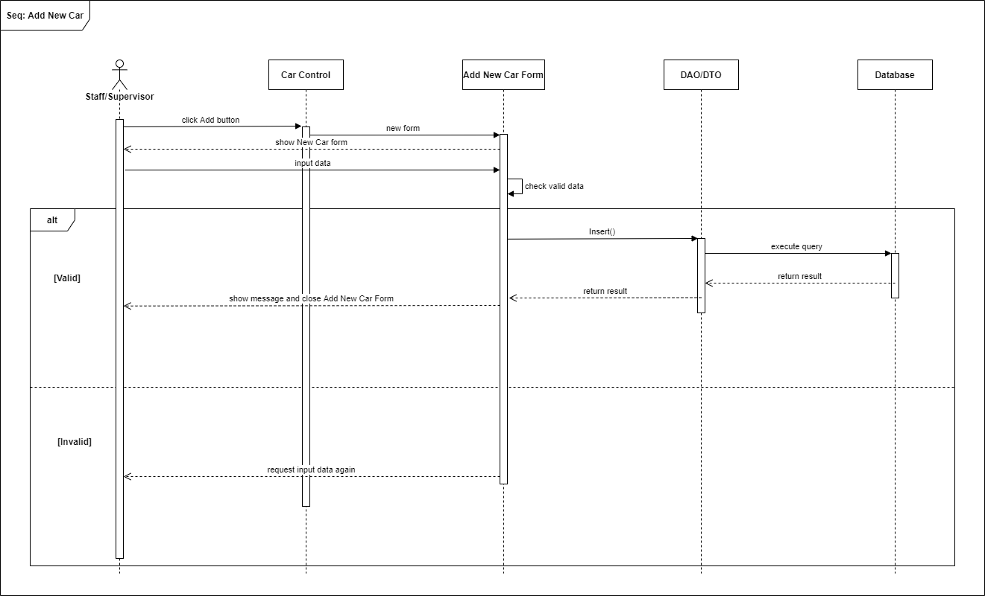

**3) Edit Car:**

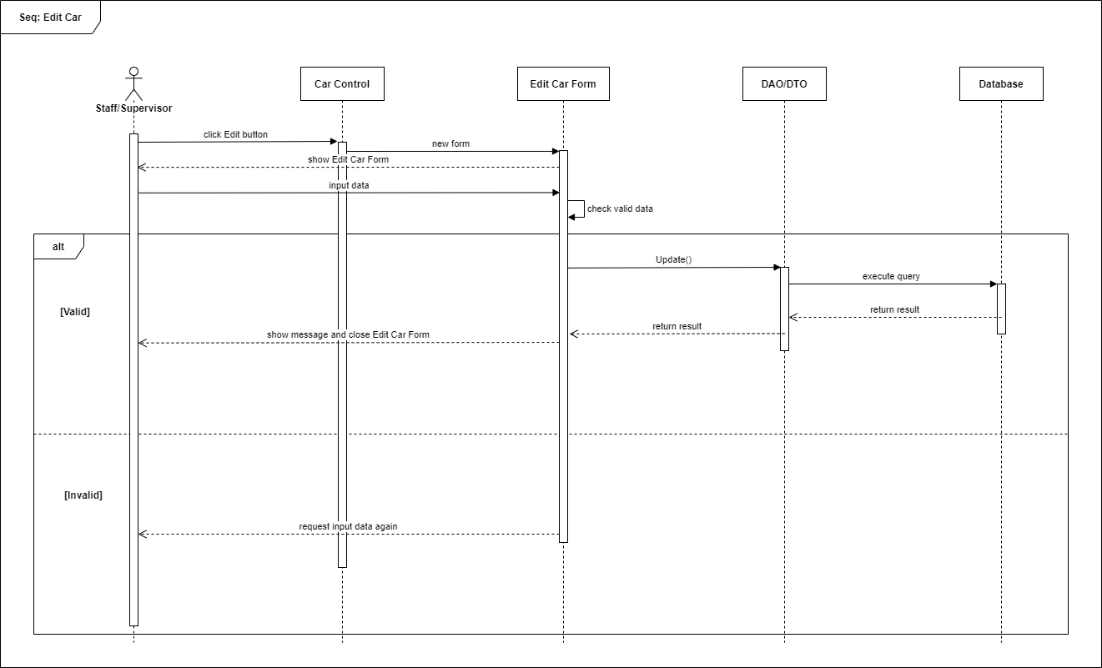

**4)Search Car:**

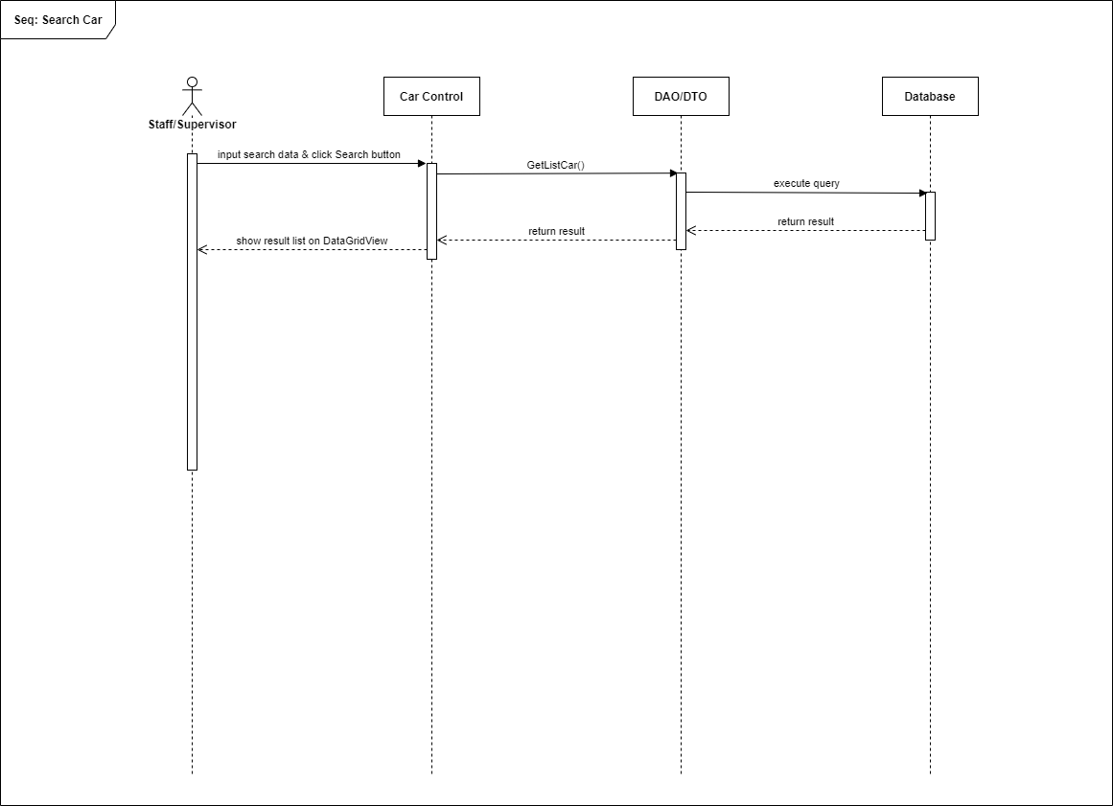

**5)Delete Car:**

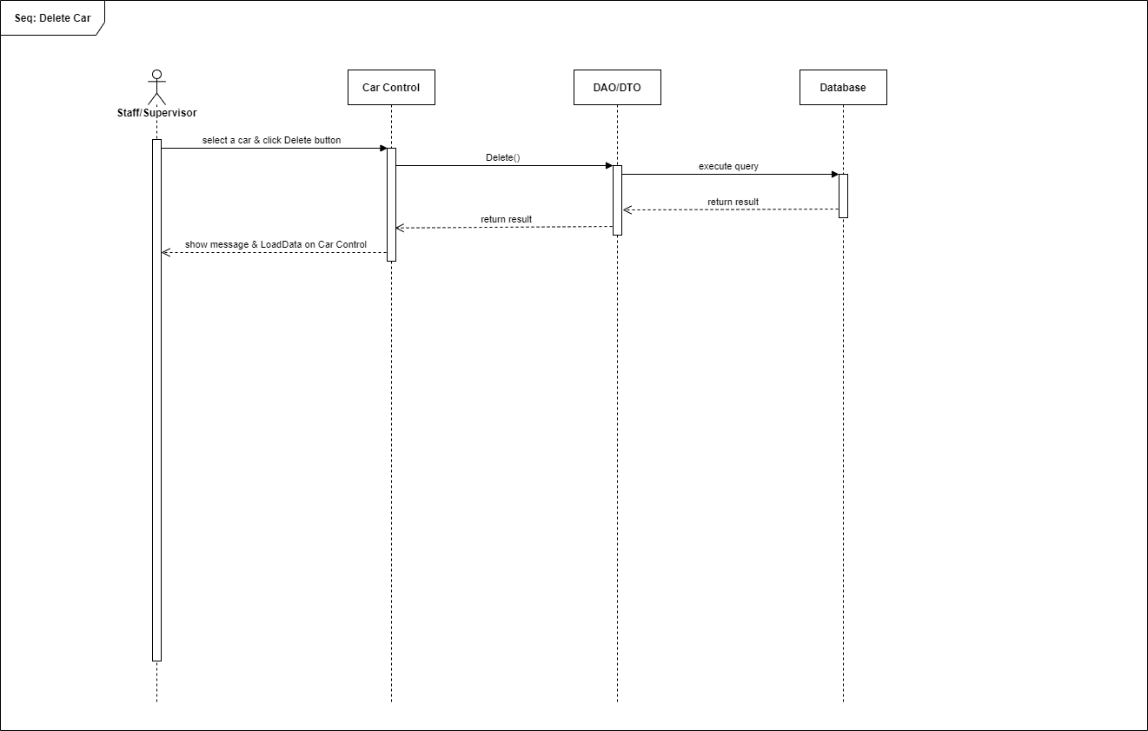

**6)Add Category:**

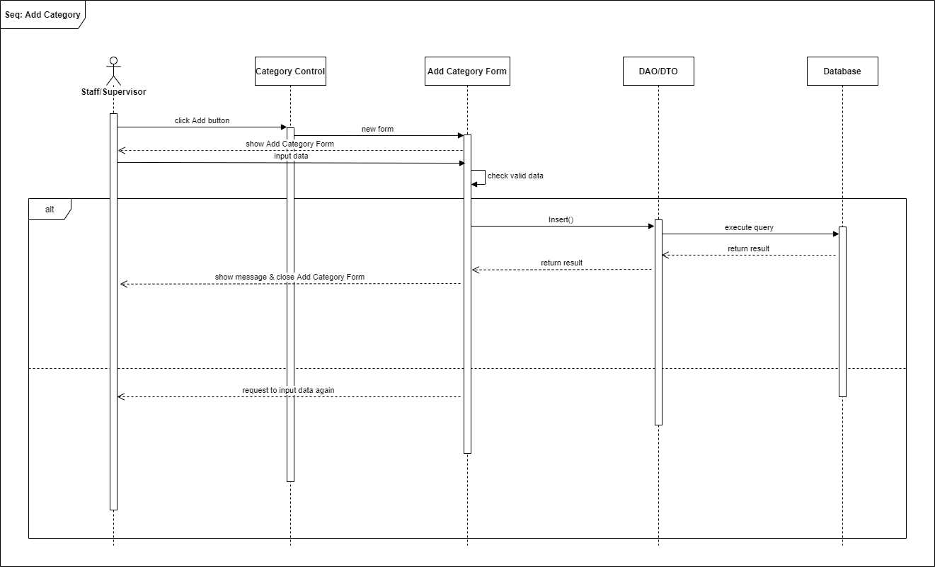

**7)Edit Category:**

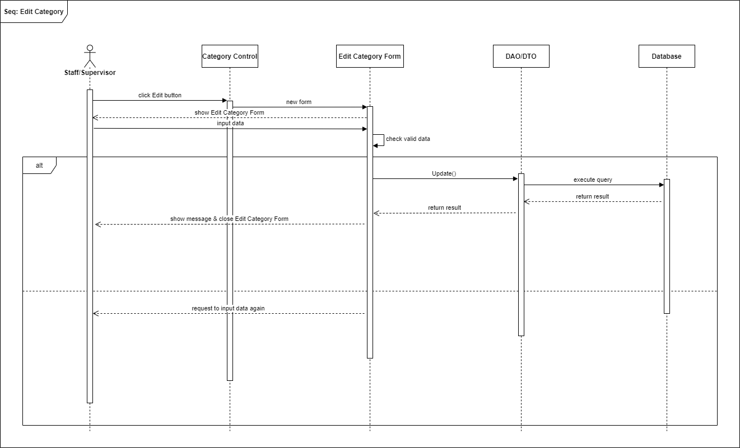

**8)Add Manufacturer:**

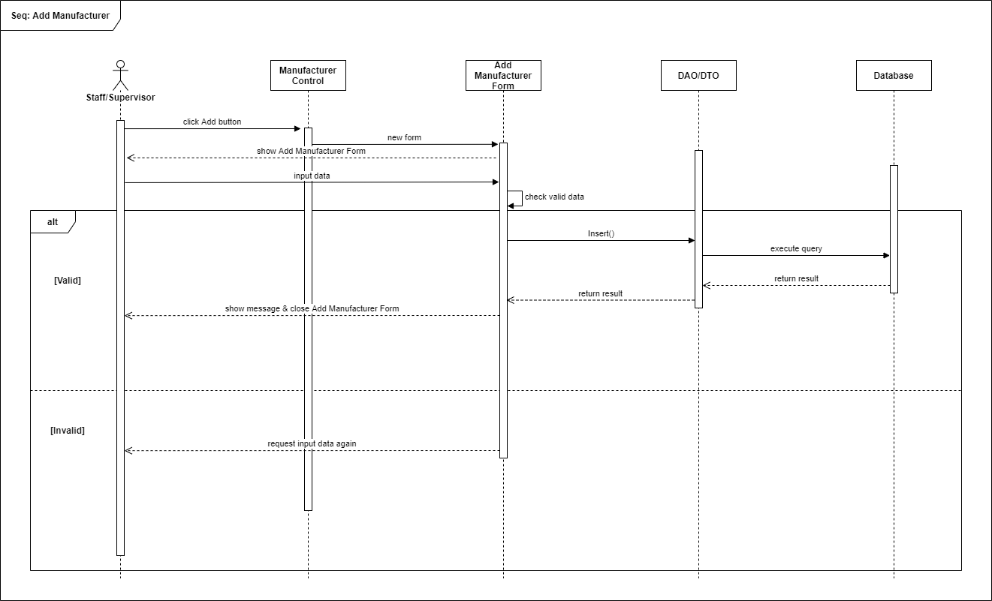

**9) Edit Manufacturer:**

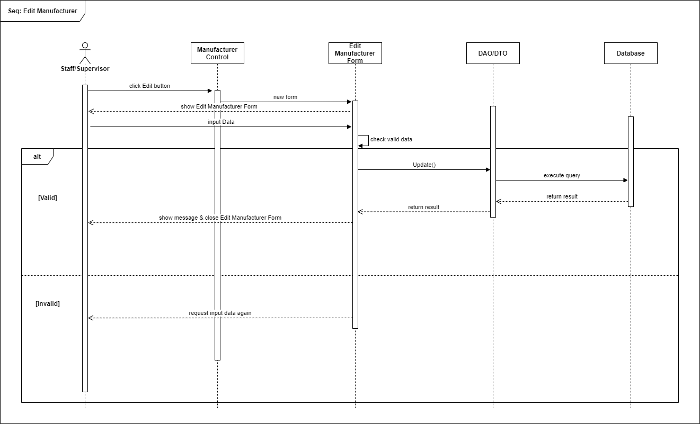

**10) Delete Manufacturer:**

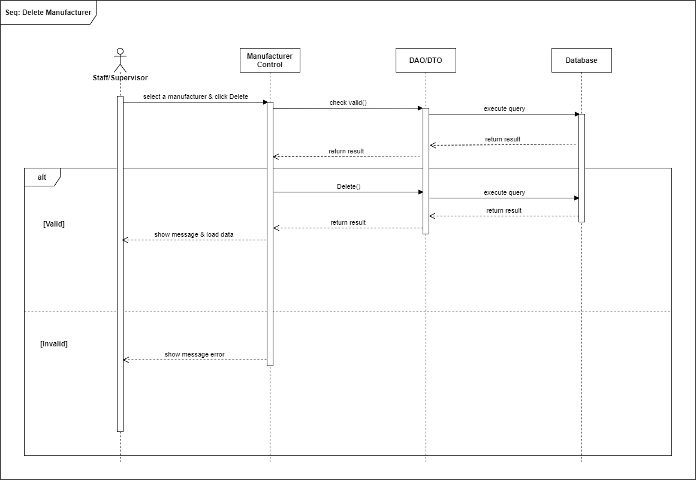

**11) Add Invoice:**

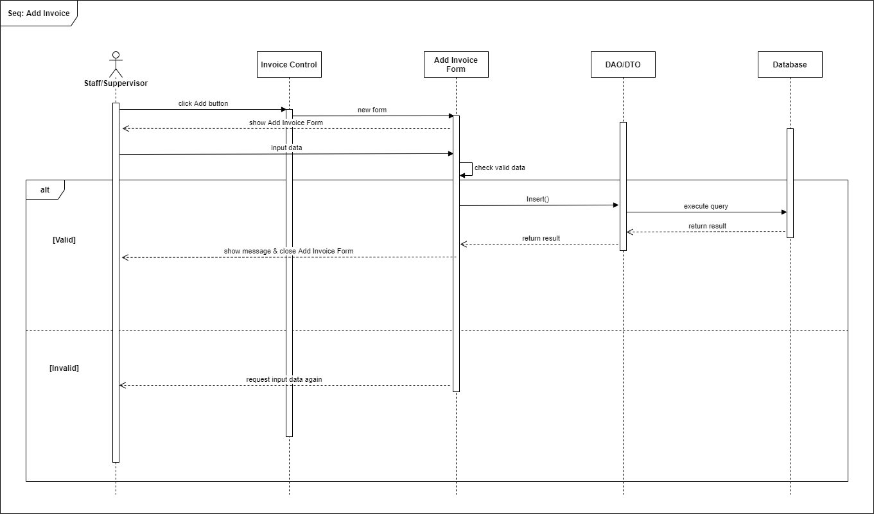

**12) View Invoice Details:**

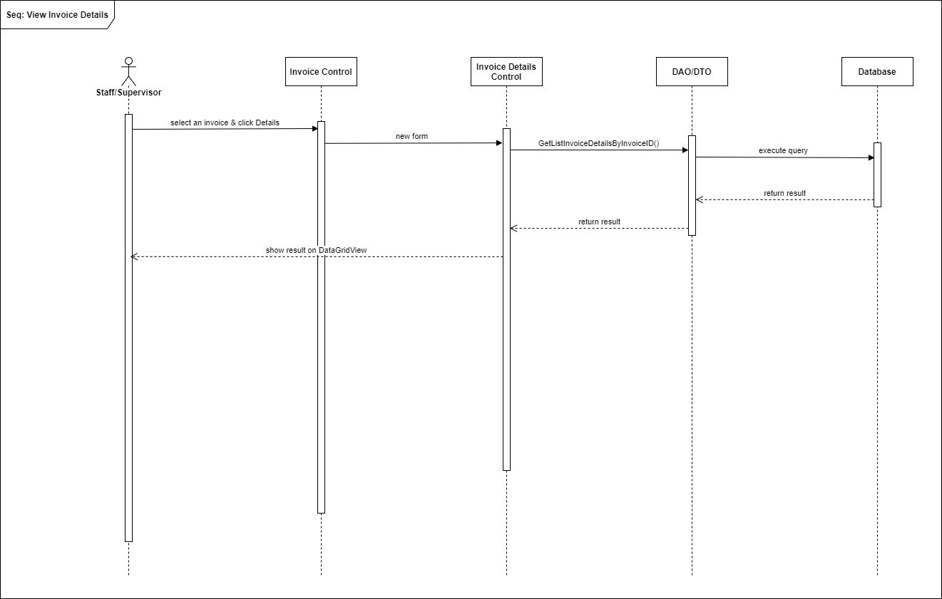

**13) View Customer List:**

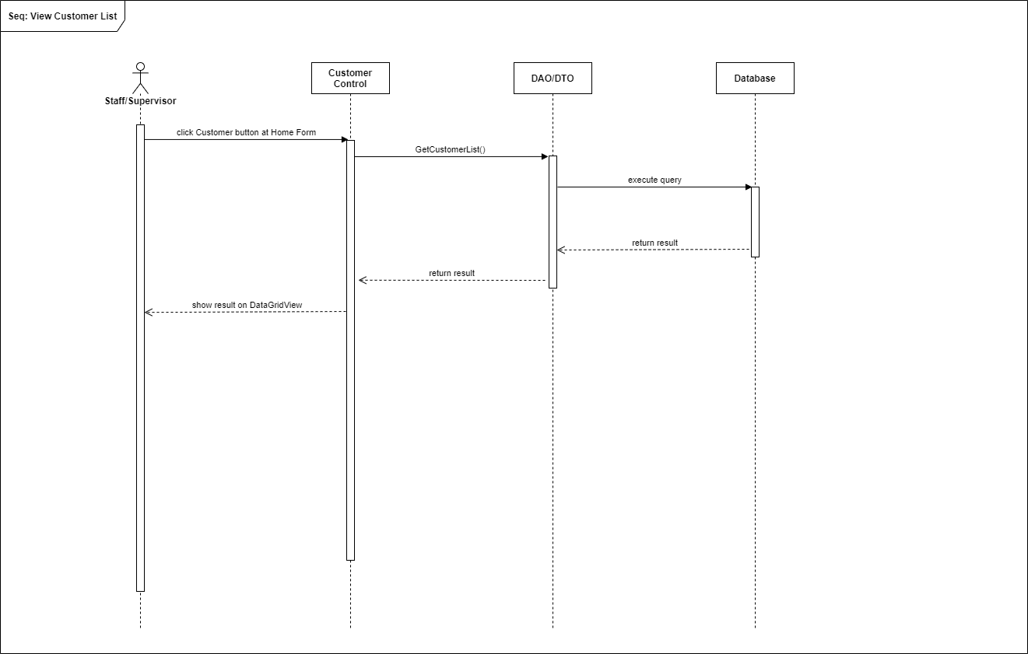

**14) View Report:**

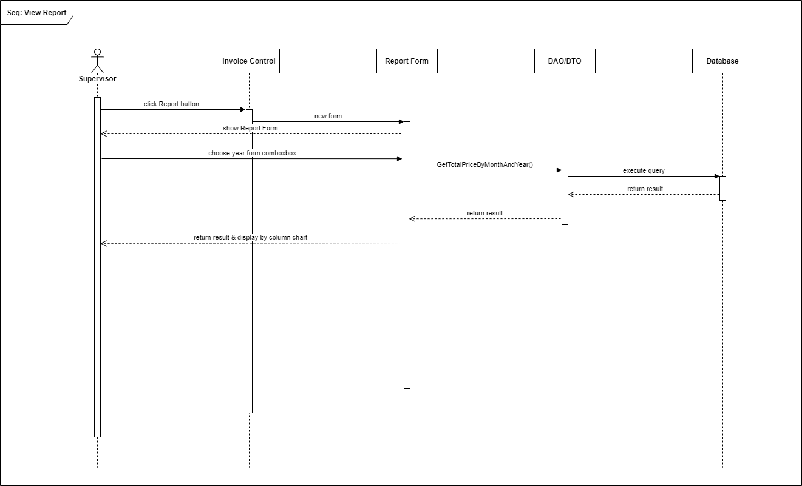

|  |  |  |
| --- | --- | --- |
| **Date: Sep 20, 2012** | **Prepared by Project Group 4**  **Team Leader:** | **Approved by**  **Mr. Ho Hoan Kiem** |
| **Signature** |  |  |

**REVIEW 3**

**INTERFACE DESIGN**

1. **Login Screen:**

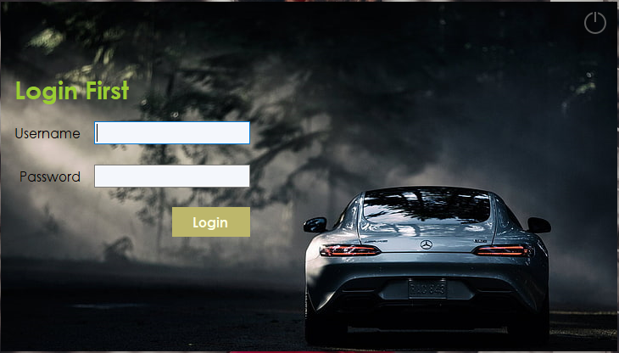

|  |  |  |  |  |  |
| --- | --- | --- | --- | --- | --- |
| **Name** | **Type** | **Event** | **Validation** | **Description** | **Status** |
| User Name | TextBox |  | String, not null | Input user name |  |
| Password | TextBox |  | String, not null, | Input Customer’s password |  |
| Login | Button |  | Click | Choose Login |  |

1. **Home Screen:**

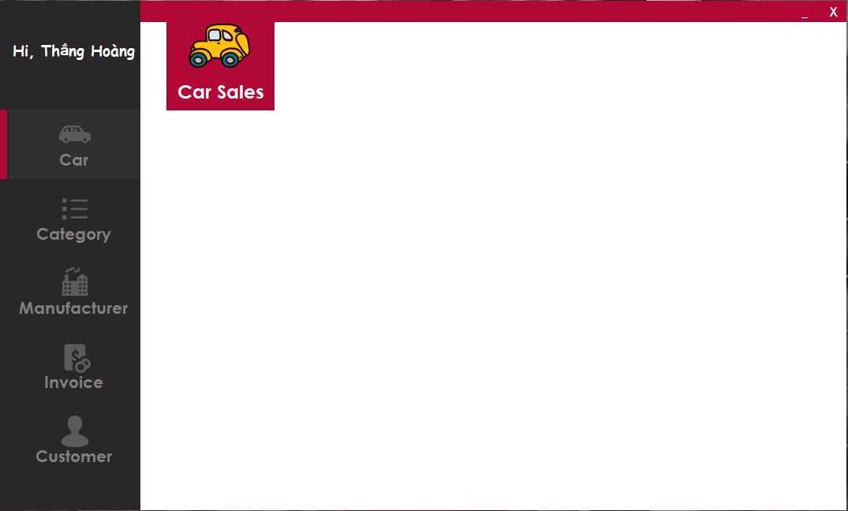

1. **Car Listing Screen:**

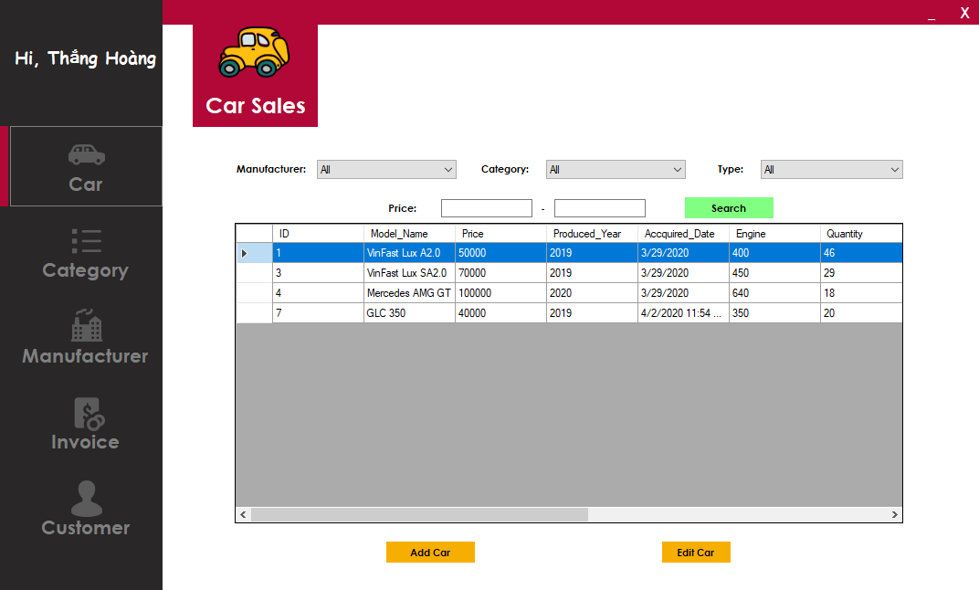

|  |  |  |  |  |  |
| --- | --- | --- | --- | --- | --- |
| **Name** | **Type** | **Event** | **Validation** | **Description** | **Status** |
| Manufacturer | Dropdownlist |  |  | Choose a manufacturer |  |
| Category | Dropdownlist |  |  | Choose a category |  |
| Type | Dropdownlist |  |  | Choose a type |  |
| Price From | TextBox |  | double | Input price From |  |
| Price To | TextBox |  | double | Input price To |  |
| Car List | Datagridview |  |  | Car List |  |
| Search | Button | onClick |  | Button Search |  |
| Add Car | Button | onClick |  | Button Add new Car |  |
| Edit Car | Button | onClick |  | Button Edit Car |  |

1. **Add new Car screen:**

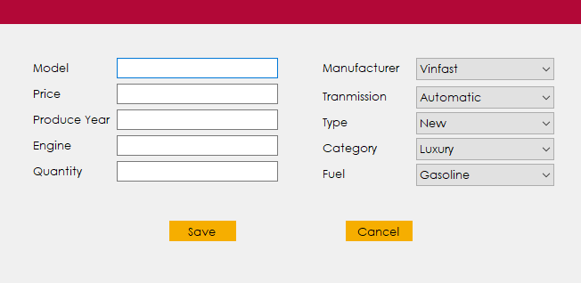

|  |  |  |  |  |  |
| --- | --- | --- | --- | --- | --- |
| **Name** | **Type** | **Event** | **Validation** | **Description** | **Status** |
| Model | TextBox |  | string, not null | Input Model name |  |
| Price | TextBox |  | double, not null | Input price |  |
| Produce Year | TextBox |  | int, not null | Input Produce Year |  |
| Engine | TextBox |  | int, not null | Input Engine |  |
| Quantity | TextBox |  | int, not null | Input Quantity |  |
| Manufacturer | Dropdownlist |  | not null | Choose a manufacturer |  |
| Category | Dropdownlist |  | not null | Choose a category |  |
| Type | Dropdownlist |  | not null | Choose a type |  |
| Transmission | Dropdownlist |  | not null | Choose a transmission |  |
| Fuel | Dropdownlist |  | not null | Choose a Fuel |  |
| Save | Button | onClick |  | Button Add new Car |  |
| Cancel | Button | onClick |  | Button Edit Car |  |

1. **Edit Car Screen:**

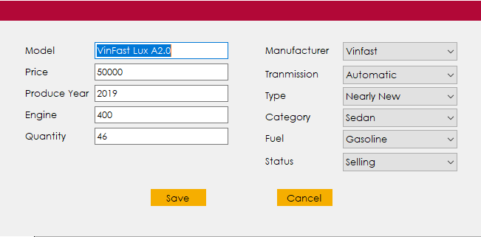

|  |  |  |  |  |  |
| --- | --- | --- | --- | --- | --- |
| **Name** | **Type** | **Event** | **Validation** | **Description** | **Status** |
| Model | TextBox |  | string, not null | Input Model name |  |
| Price | TextBox |  | double, not null | Input price |  |
| Produce Year | TextBox |  | int, not null | Input Produce Year |  |
| Engine | TextBox |  | int, not null | Input Engine |  |
| Quantity | TextBox |  | int, not null | Input Quantity |  |
| Manufacturer | Dropdownlist |  | not null | Choose a manufacturer |  |
| Category | Dropdownlist |  | not null | Choose a category |  |
| Type | Dropdownlist |  | not null | Choose a type |  |
| Transmission | Dropdownlist |  | not null | Choose a transmission |  |
| Fuel | Dropdownlist |  | not null | Choose a Fuel |  |
| Status | Dropdownlist |  | not null | Choose a Status |  |
| Save | Button | onClick |  | Button Add new Car |  |
| Cancel | Button | onClick |  | Button Edit Car |  |

1. **Category Listing Screen:**

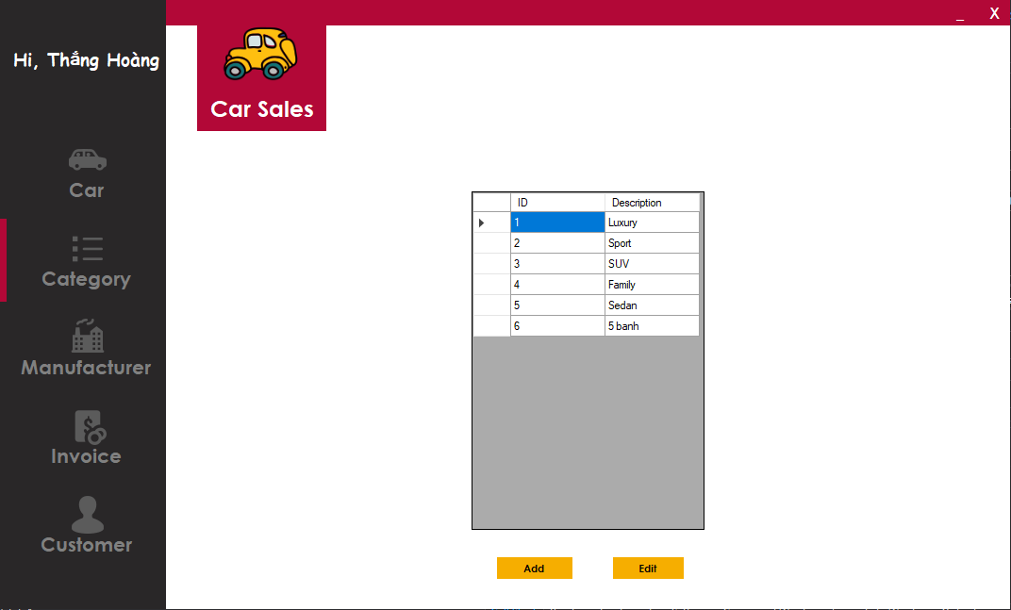

|  |  |  |  |  |  |
| --- | --- | --- | --- | --- | --- |
| **Name** | **Type** | **Event** | **Validation** | **Description** | **Status** |
| Add | Button | onClick |  | Add new Category Button |  |
| Edit | Button | onClick |  | Edit Category Button |  |

1. **Add Category:**

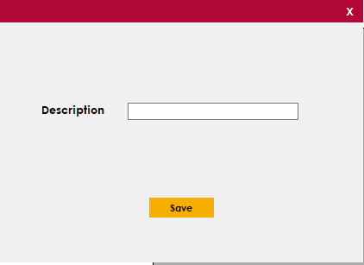

|  |  |  |  |  |  |
| --- | --- | --- | --- | --- | --- |
| **Name** | **Type** | **Event** | **Validation** | **Description** | **Status** |
| Description | Textbox |  | string, not null |  |  |
| Save | Button | onClick |  | Save button |  |

1. **Edit Category:**

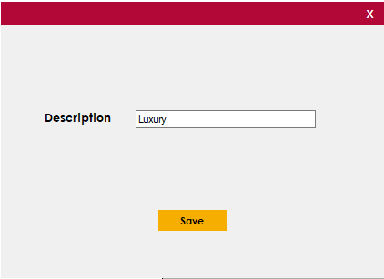

|  |  |  |  |  |  |
| --- | --- | --- | --- | --- | --- |
| **Name** | **Type** | **Event** | **Validation** | **Description** | **Status** |
| Description | Textbox |  | string, not null |  |  |
| Save | Button | onClick |  | Save button |  |

1. **Manufacturer Listing:**

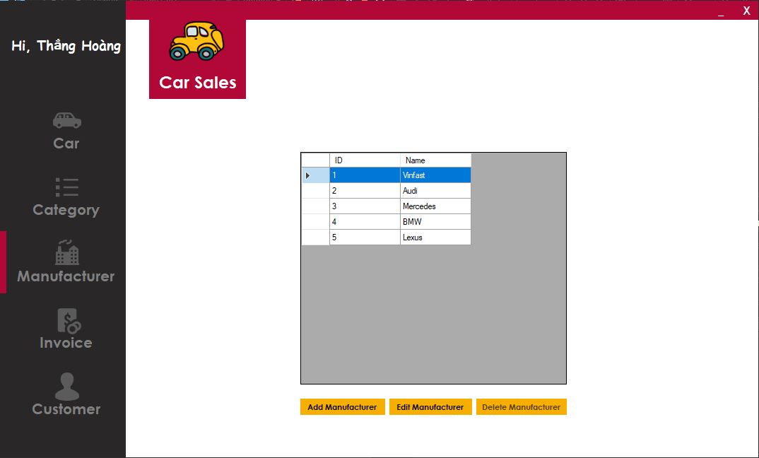

|  |  |  |  |  |  |
| --- | --- | --- | --- | --- | --- |
| **Name** | **Type** | **Event** | **Validation** | **Description** | **Status** |
| Manufacturer Listing | DataGridview |  |  | Manufacturer Listing |  |
| Add Manufacturer | Button | onClick |  | Add button |  |
| Edit Manufacturer | Button | onClick |  | Edit Button |  |
| Delete Manufacturer | Button | onClick |  | Delete button |  |

1. **Add manufacturer:**

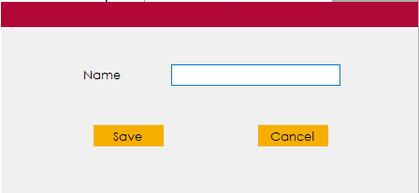

|  |  |  |  |  |  |
| --- | --- | --- | --- | --- | --- |
| **Name** | **Type** | **Event** | **Validation** | **Description** | **Status** |
| Name | Label |  |  |  |  |
| Name | Textbox |  | string, not null |  |  |
| Save | Button | onClick |  | Save Button |  |
| Cancel | Button | onClick |  | Cancelbutton |  |

1. **Edit Manufacturer:**

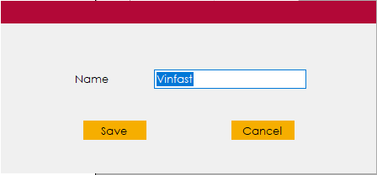

|  |  |  |  |  |  |
| --- | --- | --- | --- | --- | --- |
| **Name** | **Type** | **Event** | **Validation** | **Description** | **Status** |
| Name | Label |  |  |  |  |
| Name | Textbox |  | string, not null |  |  |
| Save | Button | onClick |  | Save Button |  |
| Cancel | Button | onClick |  | Cancelbutton |  |

1. **Invoice Listing:**

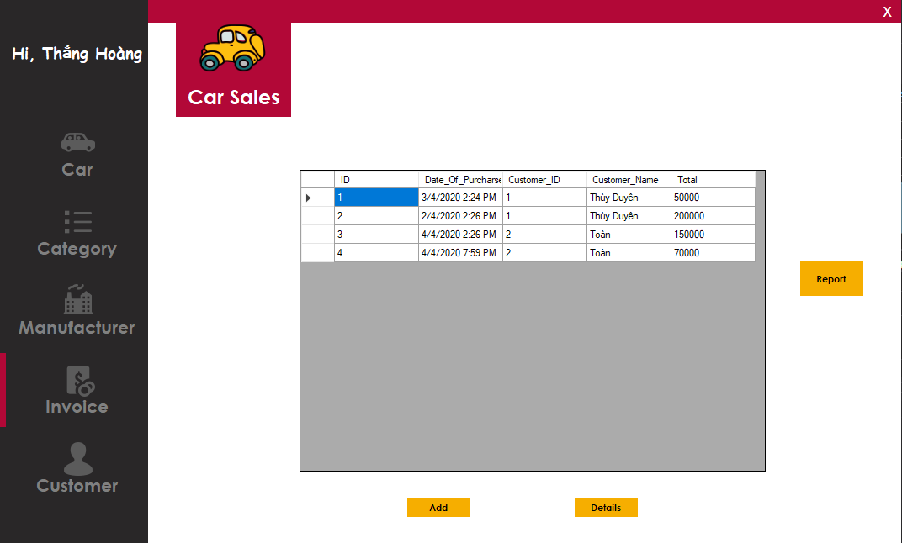

|  |  |  |  |  |  |
| --- | --- | --- | --- | --- | --- |
| **Name** | **Type** | **Event** | **Validation** | **Description** | **Status** |
| Invoice Listing | DataGridview |  |  | Invoice Listing |  |
| Add | Button | onClick |  | Add Invoice |  |
| Details | Button | onClick |  | View Details Invoice |  |
| Report | Button | onClick |  | View report |  |

1. **Add Invoice:**

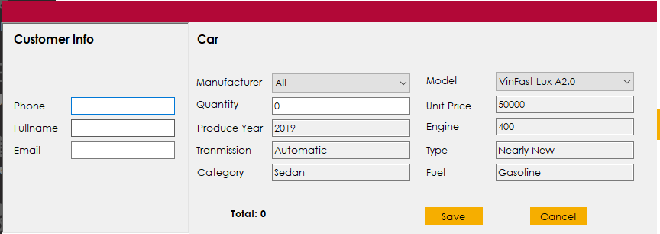

|  |  |  |  |  |  |
| --- | --- | --- | --- | --- | --- |
| **Name** | **Type** | **Event** | **Validation** | **Description** | **Status** |
| Phone | TextBox | leave | String, not null, valid phone number | Customer’s phone |  |
| Fullname | TextBox |  | String, not null | Customer’s name |  |
| Email | TextBox | leave | String, not null, valid mail | Customer’s mail |  |
| Manufacturer | Dropdownlist | selectedIndexChange | not null | Choose a manufacturer |  |
| Model | Dropdownlist | selectedIndexChange | not null | Choose a Model |  |
| Quantity | TextBox | leave | int, not null | Input Quantity |  |
| Produce year | TextBox |  | int | Auto fill |  |
| Engine | TextBox |  | int | Auto fill |  |
| Transmission | TextBox |  | string | Auto fill |  |
| Type | TextBox |  | string | Auto fill |  |
| Category | TextBox |  | string | Auto fill |  |
| Fuel | TextBox |  | string | Auto fill |  |
| Total | Label |  | string | Total price |  |
| Save | Button | onClick |  | Save button |  |
| Cancel | Button | onClick |  | Cancel button |  |

1. **Invoice Details:**

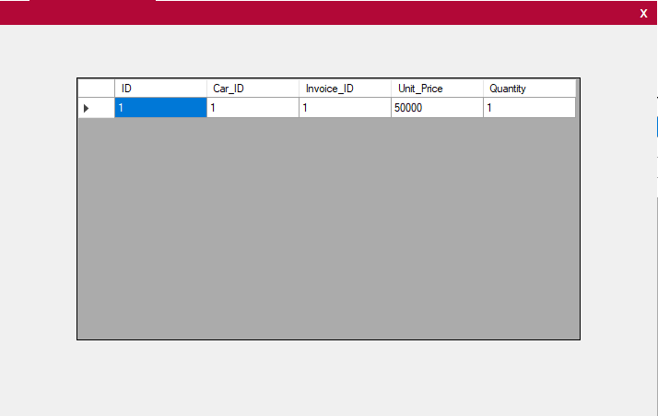

|  |  |  |  |  |  |
| --- | --- | --- | --- | --- | --- |
| **Name** | **Type** | **Event** | **Validation** | **Description** | **Status** |
| Invoice Details Listing | DataGridView |  |  | Invoice Details |  |

1. **Report:**

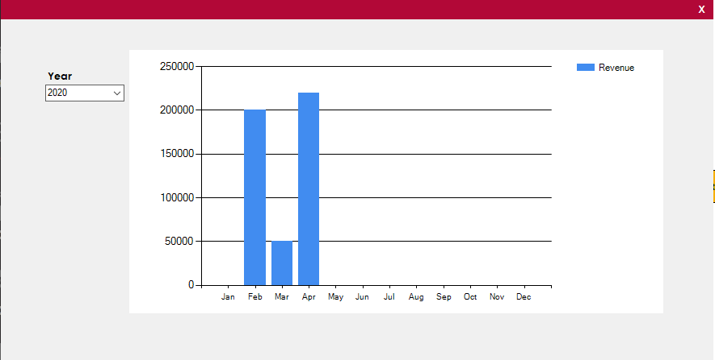

|  |  |  |  |  |  |
| --- | --- | --- | --- | --- | --- |
| **Name** | **Type** | **Event** | **Validation** | **Description** | **Status** |
| Revenue table | Chart |  |  | Revenue table |  |
| Year | Dropdownlist | selectedIndexChange |  | Choose a Year |  |

1. **Customer listing:**

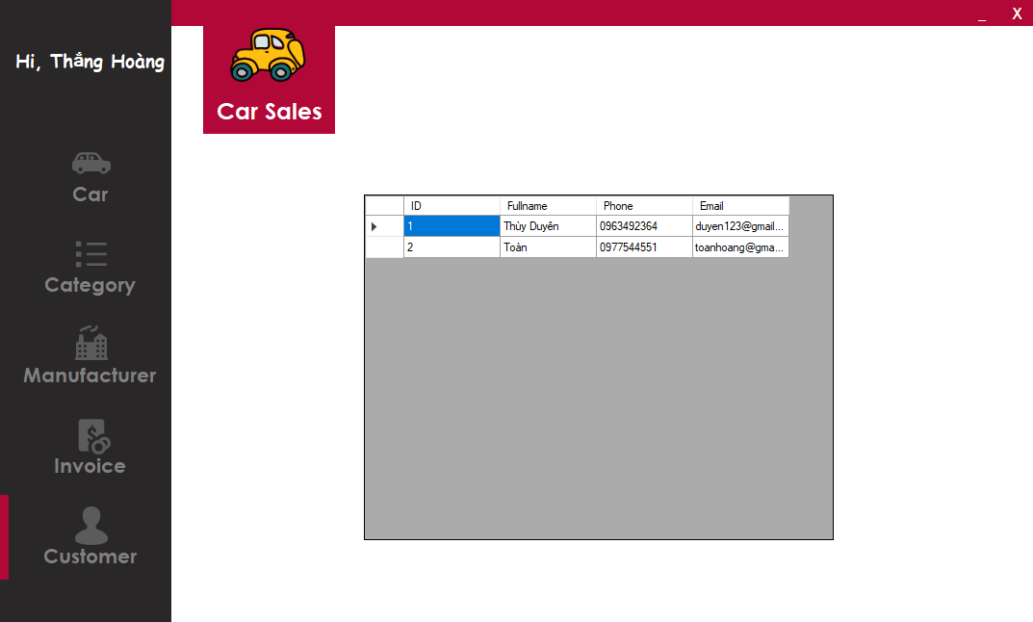

|  |  |  |  |  |  |
| --- | --- | --- | --- | --- | --- |
| **Name** | **Type** | **Event** | **Validation** | **Description** | **Status** |
| Customer Listing | DataGridView |  |  | Customer Listing |  |

**TASK SHEET**

|  |  |  |  |  |  |  |
| --- | --- | --- | --- | --- | --- | --- |
| **Project Group 01** | | **Car Management** | | **Date of Preparation** | | **Activity Plan Prepared by**  **Hoang Anh Thang** |
| **No** | **Task Title** | | **Planned Start Date** | **Planned Completed Date** | **Team Mate Names** | **Status** |
| 1 | Login | | March 30, 2020 | April 5, 2020 | Hoang Anh Thang |  |
| 2 | Design Home Screen | | Van Thanh Phuong Dat |  |
| 3 | Load Car Listing | | Hoang Anh Thang |  |
| 4 | Add New Car | |  |
| 5 | Edit a Car | |  |
| 6 | Delete Car | |  |
| 7 | Load Category Listing | | Van Thanh Phuong Dat |  |
| 8 | Add New Category | |  |
| 9 | Edit Category | |  |
| 10 | Load Manufacturer Listing | | Hoang Anh Thang |  |
| 11 | Add New Manufacturer | |  |
| 12 | Edit Manufacturer | |  |
| 13 | Delete Manufacturer | |  |
| 14 | Load Invoice Listing | | Van Thanh Phuong Dat |  |
| 15 | Add New Invoice | | Hoang Anh Thang |  |
| 16 | View Details an Invoice | | Van Thanh Phuong Dat |  |
|  |
| 17 | Report Revenue | |  |
| 18 | Load Customer Listing | | Van Thanh Phuong Dat |  |

|  |  |  |
| --- | --- | --- |
| **Date: March 30, 2020** | **Prepared by Project Group 1**  **Team Leader:** | **Approved by**  **Mr. Ho Hoan Kiem** |
| **Signature** |  |  |